What is Artificial Intelligence?
Artificial Intelligence (AI) is the simulation of human intelligence & capabilities by computer software.

What is Machine Learning?
Machine Learning is a subcategory of AI where a computer software is “taught” to draw conclusions and make predictions from data.

Azure Machine Learning
- Cloud-based platform for creating, managing and publishing machine learning models
- Platform as a Service (PaaS)
- Machine Learning Workspace – top level resource
- Machine Learning Studio – web portal for end-2-end development
- Features
  - Notebooks – using Python and R
  - Automated ML – run multiple algorithms/parameters combinations, choose the best model
  - Designer – graphical interface for no-code development
  - Data & Compute – management of storage and compute resources
  - Pipelines – orchestrate model training, deployment and management tasks
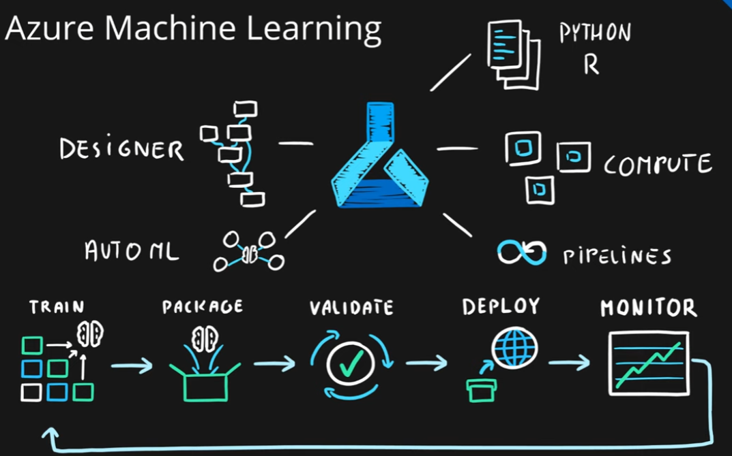
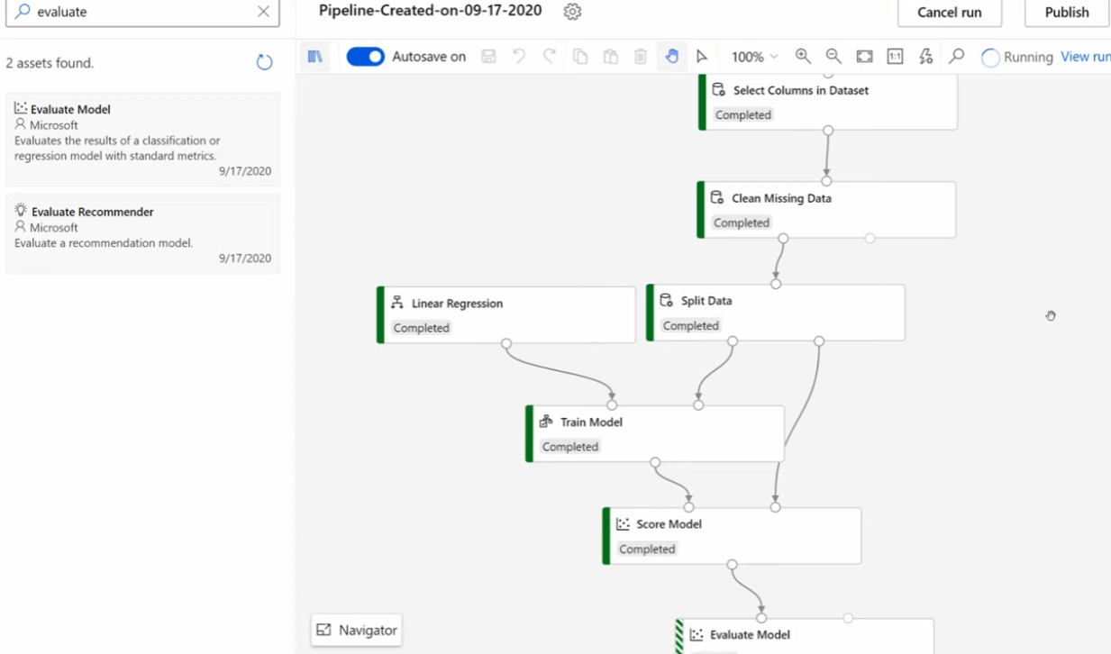
Azure Machine Learning Designer Demo

